Processes 101
Processes are the programs that are running on your machine
Managed by the kernel,where each process will have an ID associated with also known as (PID)

Viewing Processes
Command used
PS-provide list of running processes

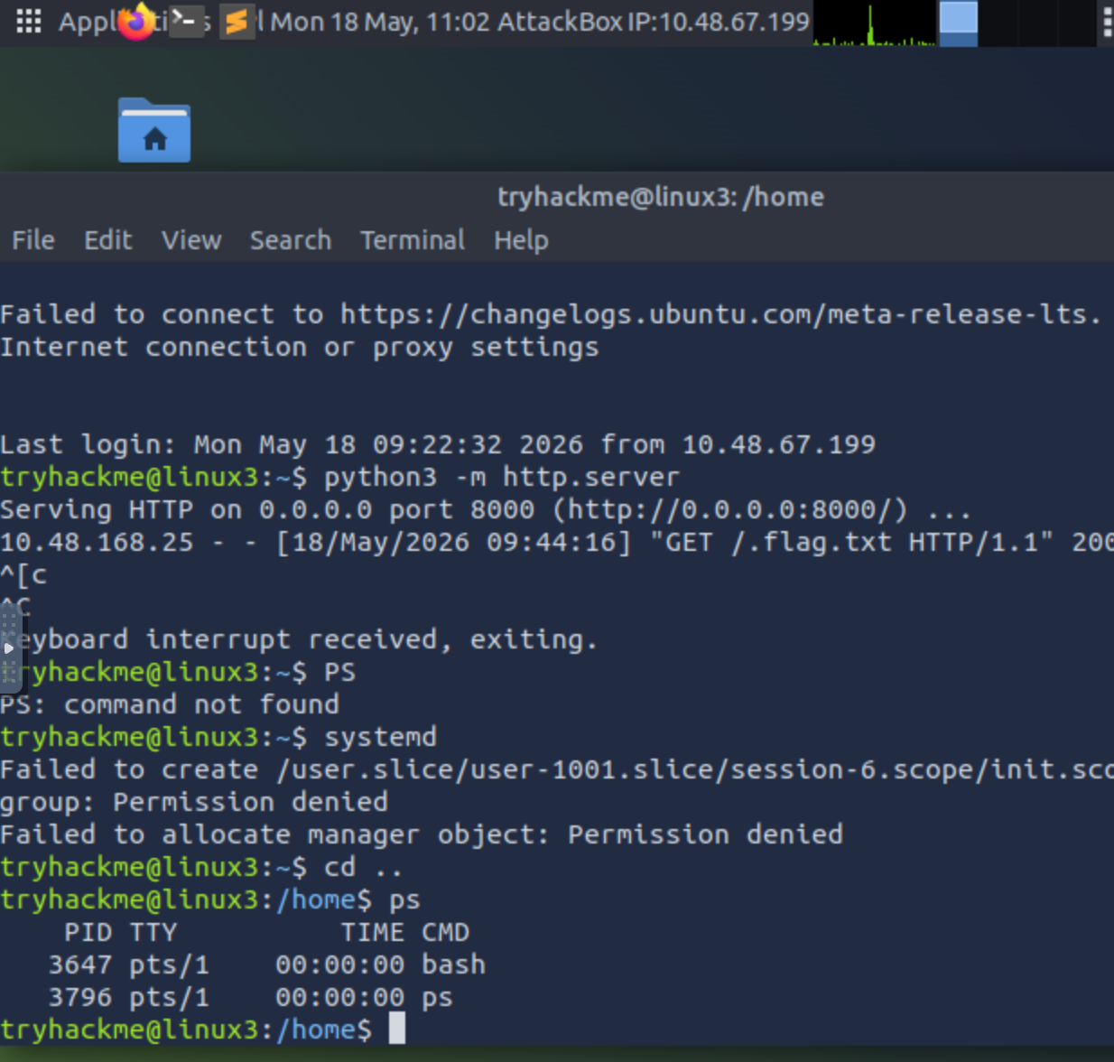

Managing Processes
Send signals that terminate processes:
- SIGTERM - Kill the process, but allow it to do some cleanup tasks beforehand
- SIGKILL - Kill the process - doesn't do any cleanup after the fact
- SIGSTOP - Stop/suspend a process

systemctl -- this command allows us to interact with the systemd process/daemon.

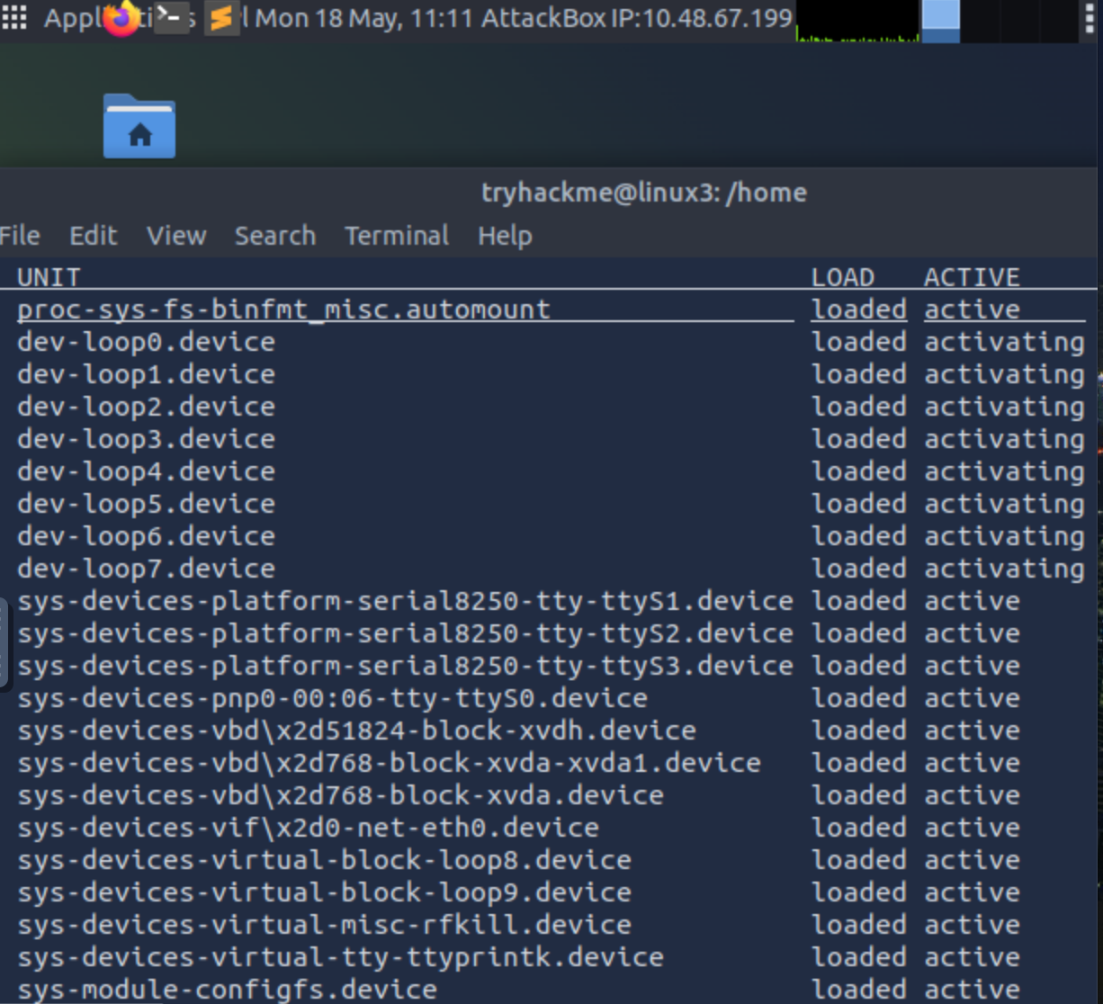
Five options with systemctl:
- Start -systemctl start
- Stop- systemctl stop

- Enable- systemctl enable

- Disable- systemctl disable

- Status- systemctl status

